

Memorandum
To: (My Boss)
From: Hunter Frady
CC: Dr. Roger Dougal

New Product Design
Here is a quick status update on that new product we are developing – the Quad-Temp Thermal Alert System. You may recall that we are developing it for a use in sensing the temperature of water. One attractive property of this new product is that it can be customized for so many different applications, just by changing out a few resistors. We can sell millions of them for so many different uses!
The circuit diagram is quite simple, as shown below, and the Bill of Materials is short and inexpensive, as shown in Table 1.
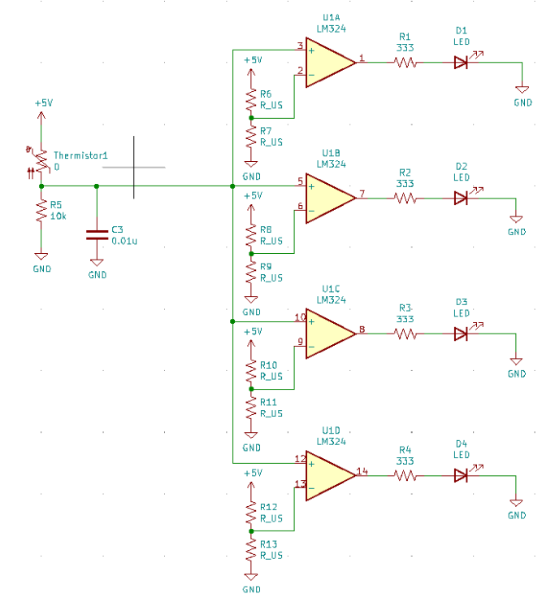
Item Name | Price per unit | # Of item | Total cost
Surface mount resistor | 0.0266 | 14 | 0.3724
Surface mount LEDs | 0.032 | 5 | 0.16
PCB (1*3 in) | 0.15 | 1 | 0.15
LM324N | 0.16 | 1 | 0.16
Thermistor | 0.02265 | 1 | 0.02265
Capacitor 0.01uF | 0.025 | 2 | 0.05
capacitor 10 uF | 0.03 | 2 | 0.06
Power pins | 0.05 | 1 | 0.05
IC Socket | 0.1 | 1 | 0.1
 |  |  | $1.12505
Table 1 contains a short list of items used in the product
We were able to cost out our parts list and come up with a materials cost. The above shows that the total material cost is about $1.13 a unit. That is without equipment cost, and labor so the price is a bit lower than it would actually be. That said if we sell them for $10 we still make a large profit. With a projected sales volume of 10 million per year, we would selling roughly 1.25 million units a year. This stands to increase our bottom line significantly. We know as we go we can refine the circuit, use some better materials and make our profit margin even larger.
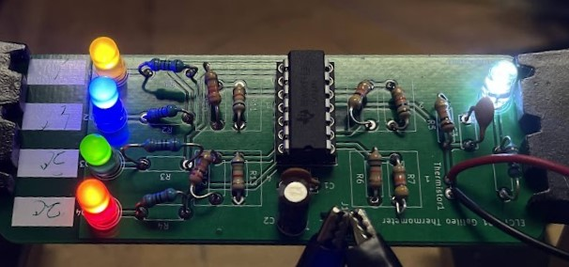
Above is a photo of the circuit that we created. The application we used it in was a water heater sensor. We set the sensors up at 20, 30, 40, 50 C, which are relevant since 20 is room temperature, 30 is lukewarm, 40 is hot, and 50 is far too hot.
Testing the prototype showed us that it took some trial and error to get it right. Some of that is due to internal resistance of either the thermistor, or resistors themselves. Our batteries should last roughly 77 hours. The amount of time could be increased if we used more energy efficient products. My suggestion would be to get a rectifier to hook up to the AC power coming into the house. This would allow us to not worry about batteries
Now note that some of the parts we looked up were limited in quantity, and the best course of action would be to talk to digikey and try and secure a bulk contract on parts needed. Labor and equipment needed to build the circuits was also not factored in but would be significant costs.

